**INTRODUCTION:**

**1**.**Project Overview**:

The ideation phase is the foundation of the CRM application for jewel management. This document outlines the ideas, objectives, challenges, and potential solutions for the admin-related aspects of the project. The goal is to streamline administrative tasks, enhance user experience, and improve overall efficiency in jewel management

**2.Purpose:**

-Define user roles, profiles, and permissions for secure access.

- Improve user adoption through an intuitive UI and efficient workflows.

- Implement seamless flows for managing jewel inventory, sales, and customer interactions.

- Develop comprehensive reports and dashboards for business insights.

- Ensure compliance with

**IDEATION PHASE**

**Brainstroming & Idea Prioritization**

|  |  |
| --- | --- |
| Date | 31 January 2025 |
| Team ID | LTVIP2025TMID19428 |
| Project Name | CRM Application for jewel management |
| Maximum Marks | 4 Marks |

**Brainstroming & Idea Prioritization**:

Brainstorming provides a free and open environment that encourages everyone within a

team to participate in the creative thinking process that leads to problem solving.

Prioritizing volume over value, out-of-the-box ideas are welcome and built upon, and all

participants are encouraged to collaborate, helping each other develop a rich amount of

creative solutions.

**Step-1: Team Gathering,Collaboration and Select the Problem Statement**:

Problem Statement:

Users and administrators in the jewel management CRM application face challenges in efficiently managing roles, profiles, user access, and adoption due to a lack of intuitive workflows and reporting mechanisms. This results in decreased operational efficiency, limited visibility into user activity, and difficulty in tracking key performance metrics 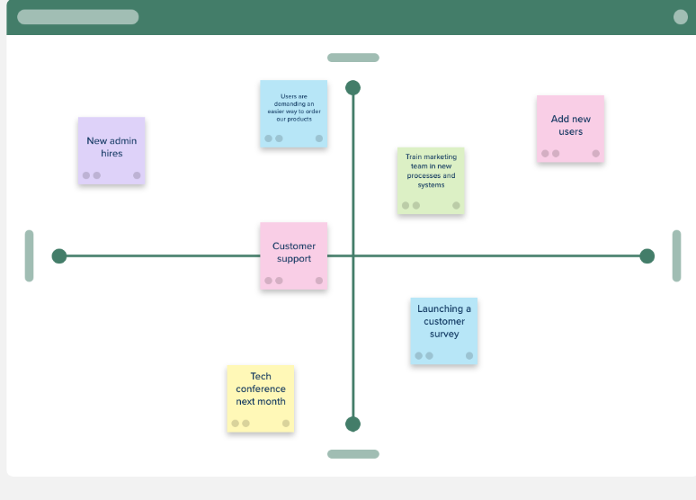

**Step-2: Brainstorm, idea Listing and Grouping**:

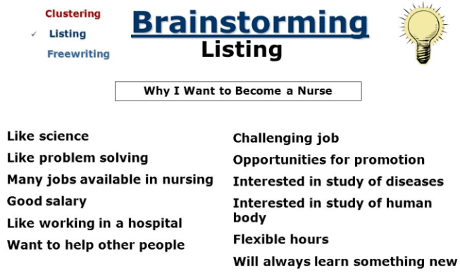

**Step-3: Idea Prioritization**

Idea prioritization is the process of evaluating and ranking ideas based on their potential value and feasibility. It is a method of ranking ideas in order of importance, based on specific criteria established by the organization. Idea prioritization infers that you have an idea management process in place, meaning you have an established method for collecting, organizing, and evaluating requests for new features and enhancements.

**Define the Problem Statements**

|  |  |
| --- | --- |
| Date | 31 January |
| Team ID | LTVIP2025TMID19428 |
| Project Name | CRM Application for jewel management |
| Maximum Marks | 2 Marks |

**Customer Problem Statement:**

|  |  |  |  |  |  |
| --- | --- | --- | --- | --- | --- |
| **Problem**  **statement** | **I am**  **(customer)** | **I’m trying to** | **But** | **Because** | **Which makes me feel** |
| **(PS)** |  |  |  |  |  |
| PS-1 | B.Kamala | Software  Engineer | security issues | Technical debt | I get excited I find something great |
| PS-2 | B.Sireesha | IAS | corruption | Poltical interference | A sense of fullfilment |

**Empathize & discover**

Empathy Map Canvas: This empathy map focuses on User Adoption within the CRM application for jewel management (admin side). It captures the experiences, challenges, and expectations of users adapting to the CRM system, understanding dashboards, reports, and workflows.

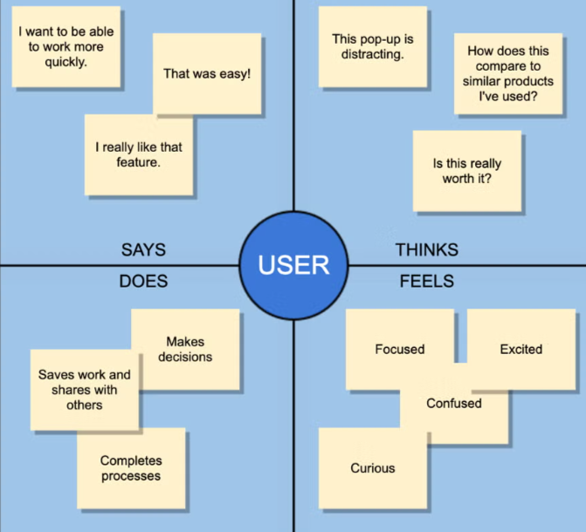

**CONCLUSION** :

The ideation phase has identified the key objectives, challenges, and solutions for the admin aspects of the CRM application for jewel management. Moving forward, the next steps involve detailed planning, prototyping, and validation to ensure a successful implementation

**THANKYOU SMARTBRIDGE**

**B. NAGA SAI LAKSHMI KAMALA**

**TEAM LEADER**